**BRAIN STORMING**1. What topic is each member of your group interested in? (Just a few keywords each are   
 fine!)

Name[ ] Keywords [ ]

Name[ ] Keywords [ ]

Name[ ] Keywords [ ]

Name[ ] Keywords [ ]

2. Try to converge on 2 promising topics and formulate two general research questions.

Possibility #1 [ ]

Possibility #2 [ ]

3. Evaluate the two ideas according to the following criteria.



**Possibility #2**

**Possibility #1**



Level of   
excitement

Level of   
excitement

Relevance

Relevance

Amount of work

Risk

Risk

Amount of work

Novelty/Importance of question

Novelty/Importance of question

*Don’t be intimidated by the pentagon shape. Each side of the shape represents the different criteria and you will be coloring in the space according to how much you feel that criteria. After coloring them in, you can compare the two possibilities and choose according to how they are colored in.*

Like this: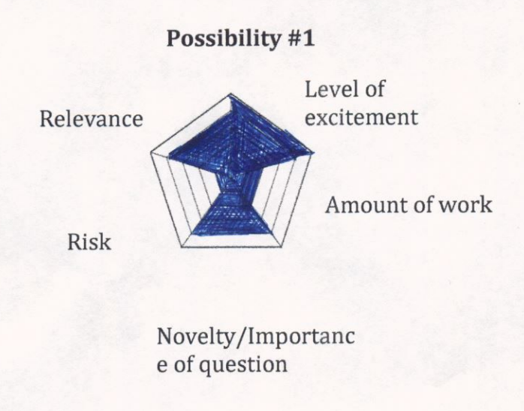

**Novelty/Importance of question**: How novel would your results be? Would they be of interest to a general research community?  
**Level of excitement:** How excited are you with finding out an answer to your question?

**Amount of work:** How much work would it incur? Is it feasible to find an answer in 2 weeks?

**Risk:** How likely is it that you can actually answer your question?   
**Relevance:** How relevant is the question to the class contents? Is it related to any of the topics we discussed in the class?

4. Overall, which question is more promising? [ ]

5. Let’s brainstorm about what you need to do to address the question.  
a. How many children do you need to look at? [1 / 2 / 3 / 4 / 5]

b. Do you need to look at children? Adults? Both? [chid(ren), adult(s), both]

c. What’s the age range are you going to look at? [ ]

d. Are there any other criteria you are using to select your target dataset?

(e.g., gender, race, dialect, language, monolingual/bilingual, dialogue/monologue)

e. What kinds of linguistic elements do you need to extract from the dataset?